Enterprise Resource Plan Solution Project

( Django Application with Gunicorn, Docker, and Nginx )

Written by Apollo

2025.3.1

Table of contents.

1. Overview. 3

2. Project Structure. 9

# 1. Overview.

- Dashboard

It shows today’s attendance for the company work.

# 

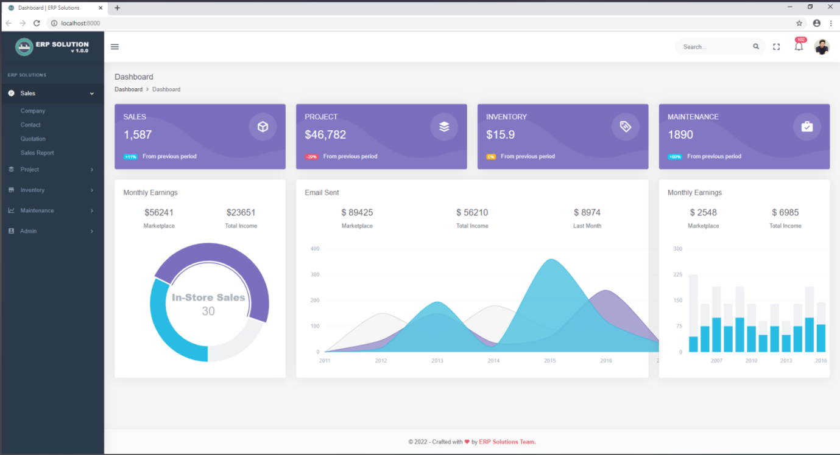

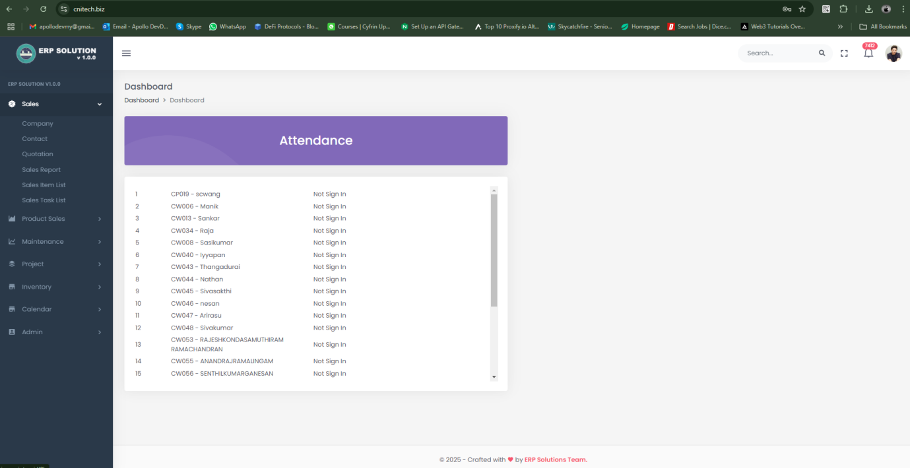

- Sales management

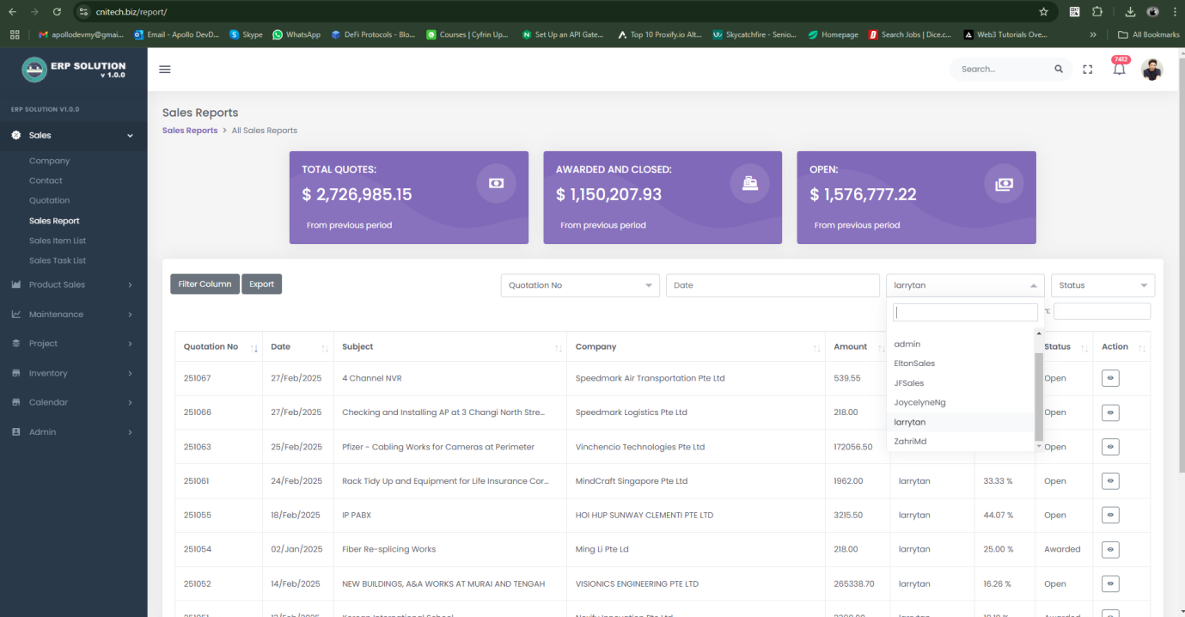

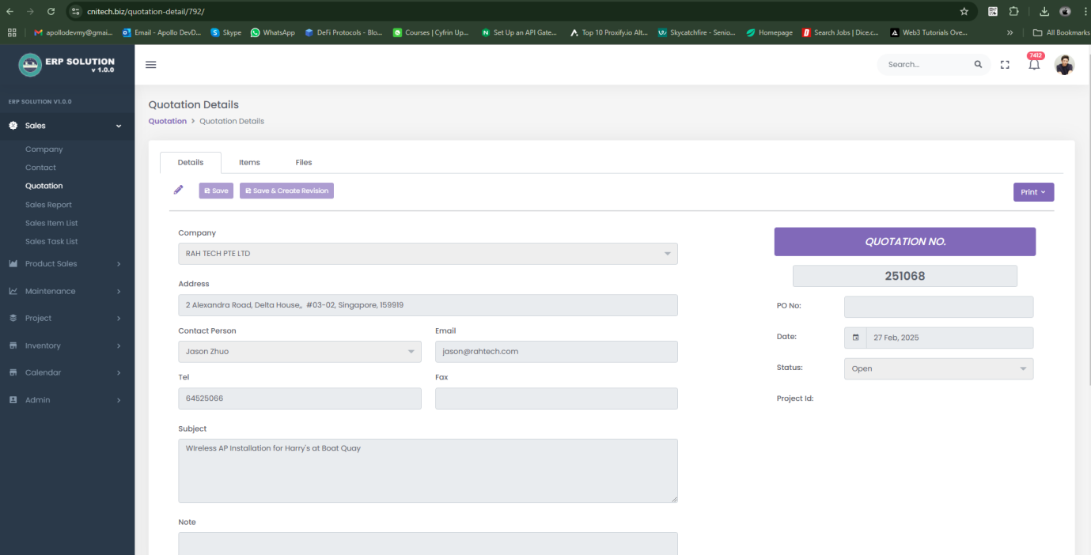

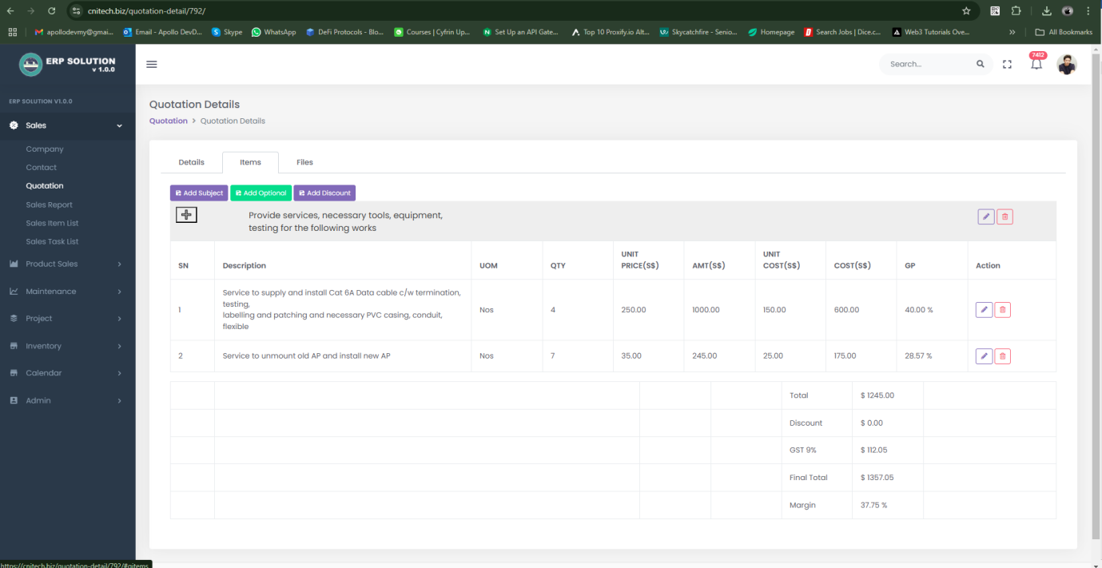

- Project Management  
Monitoring and adjust the project detail, worklog, Overtime work and so on.

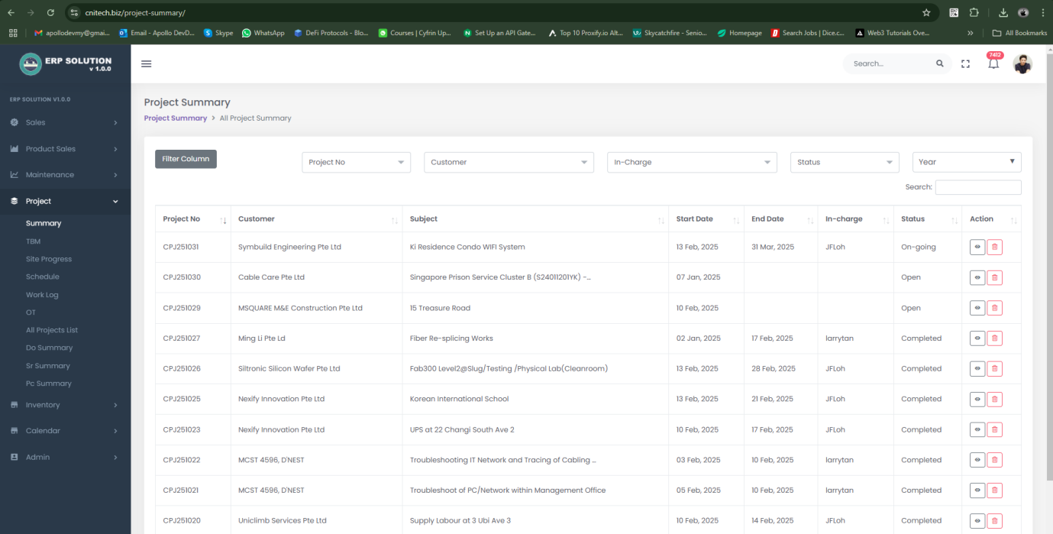  
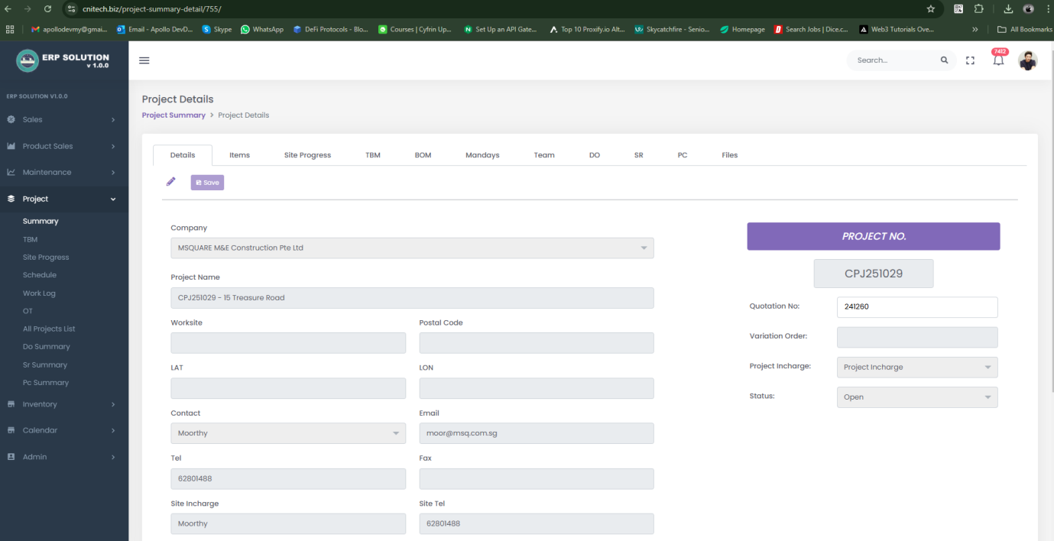

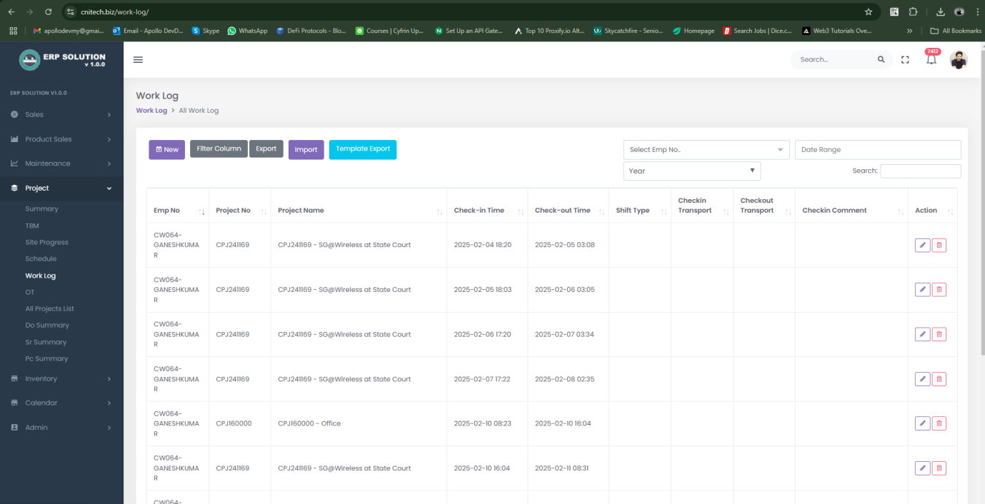

- Inventory management.  
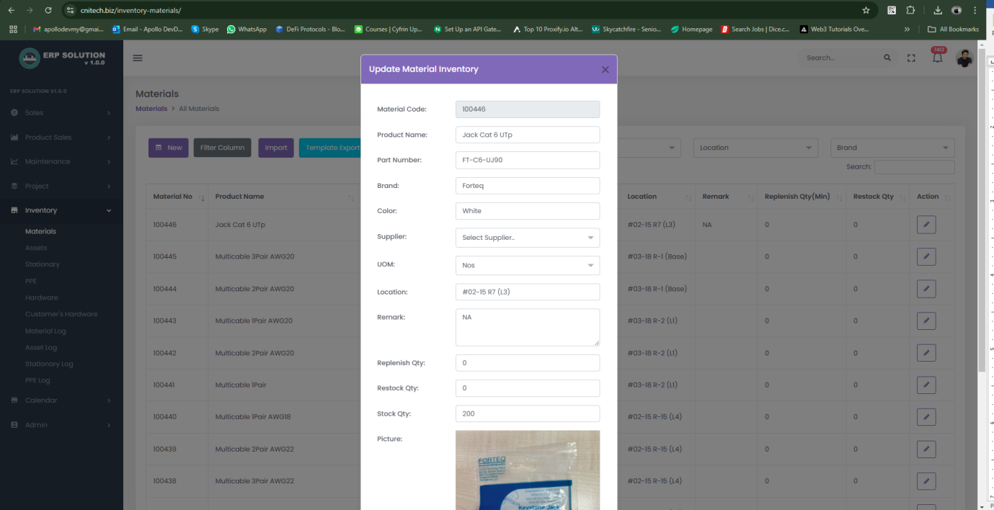  
  
- Schedule management.  
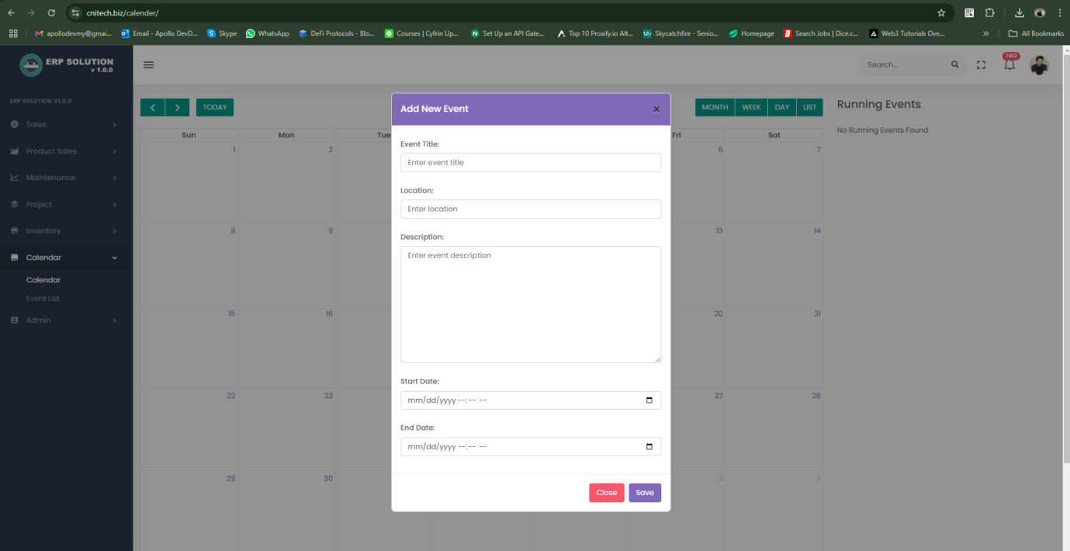

- Financial Management  
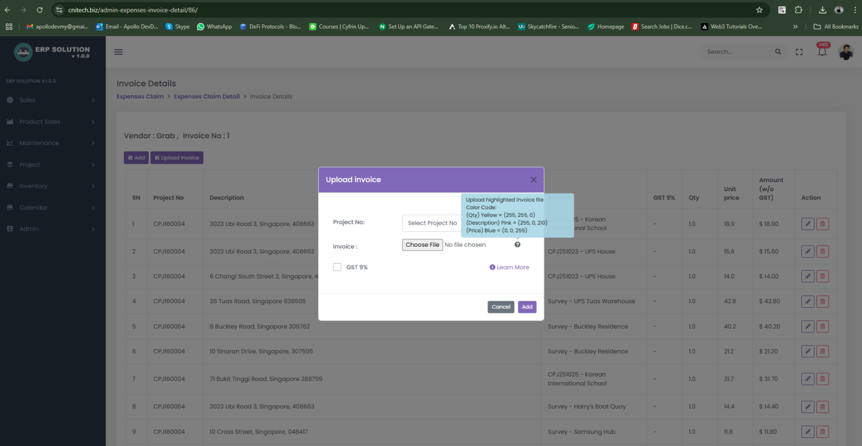  
OCR based invoice scan and integrated with Quickbook API.   
  
- Android App for Users.  
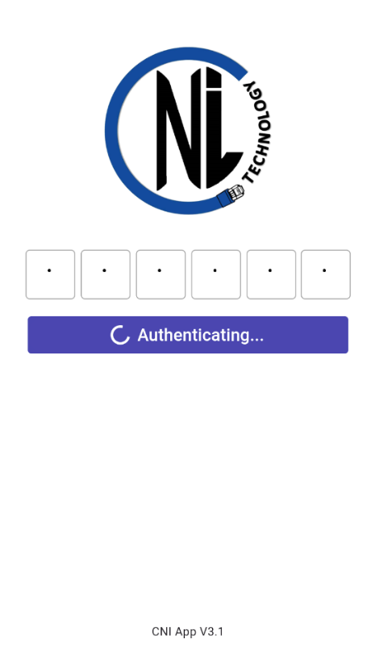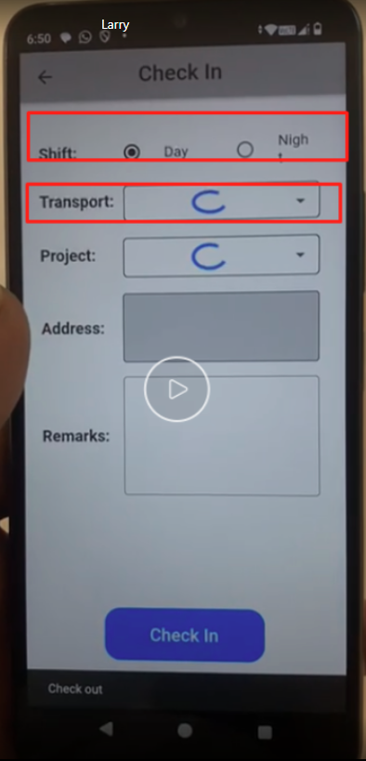

# 2. Project Structure.

